Profile and Permissions
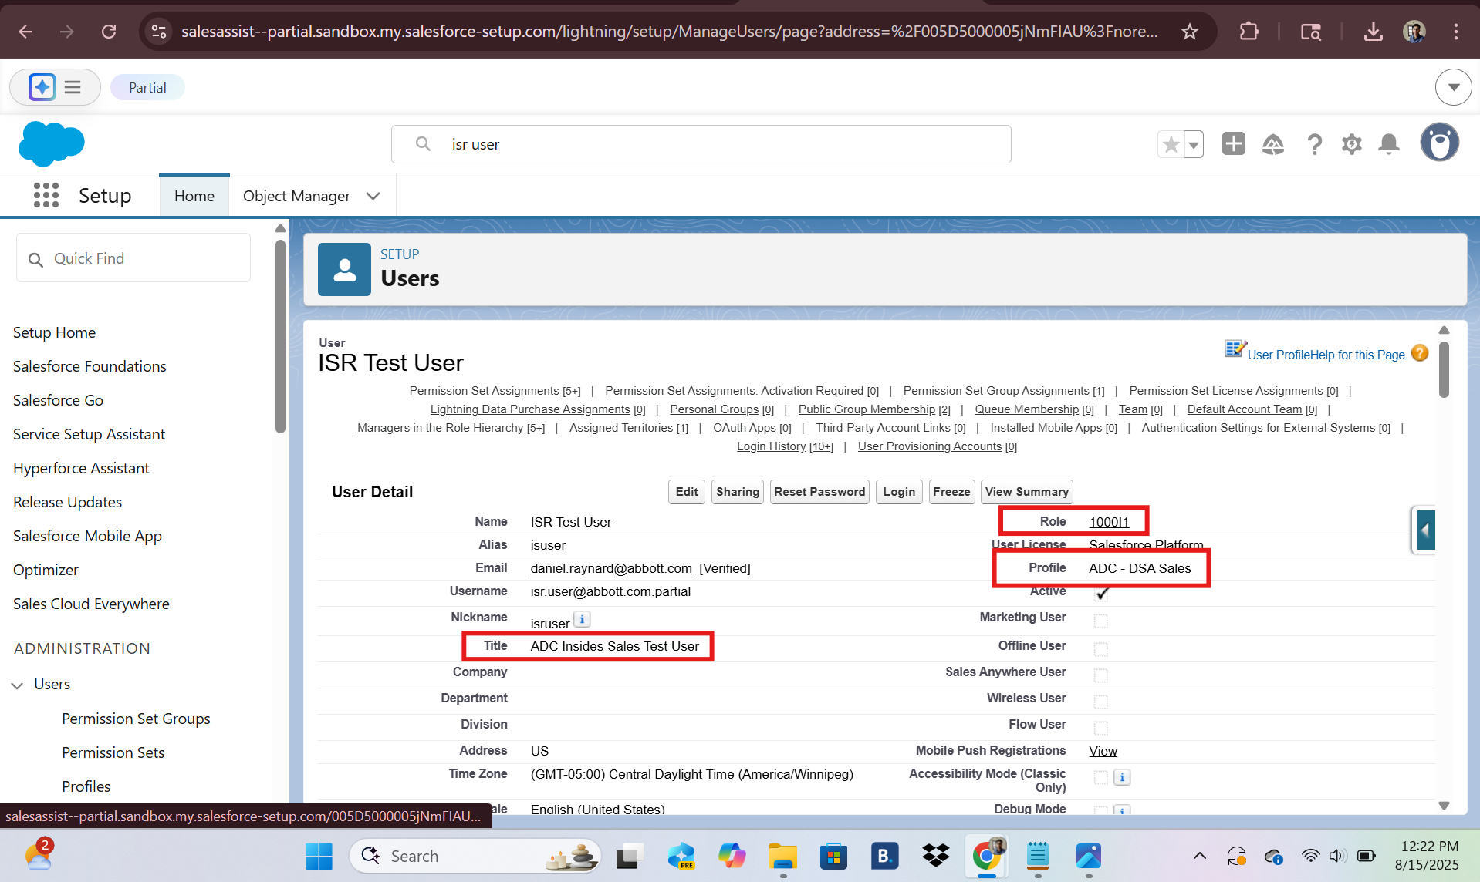
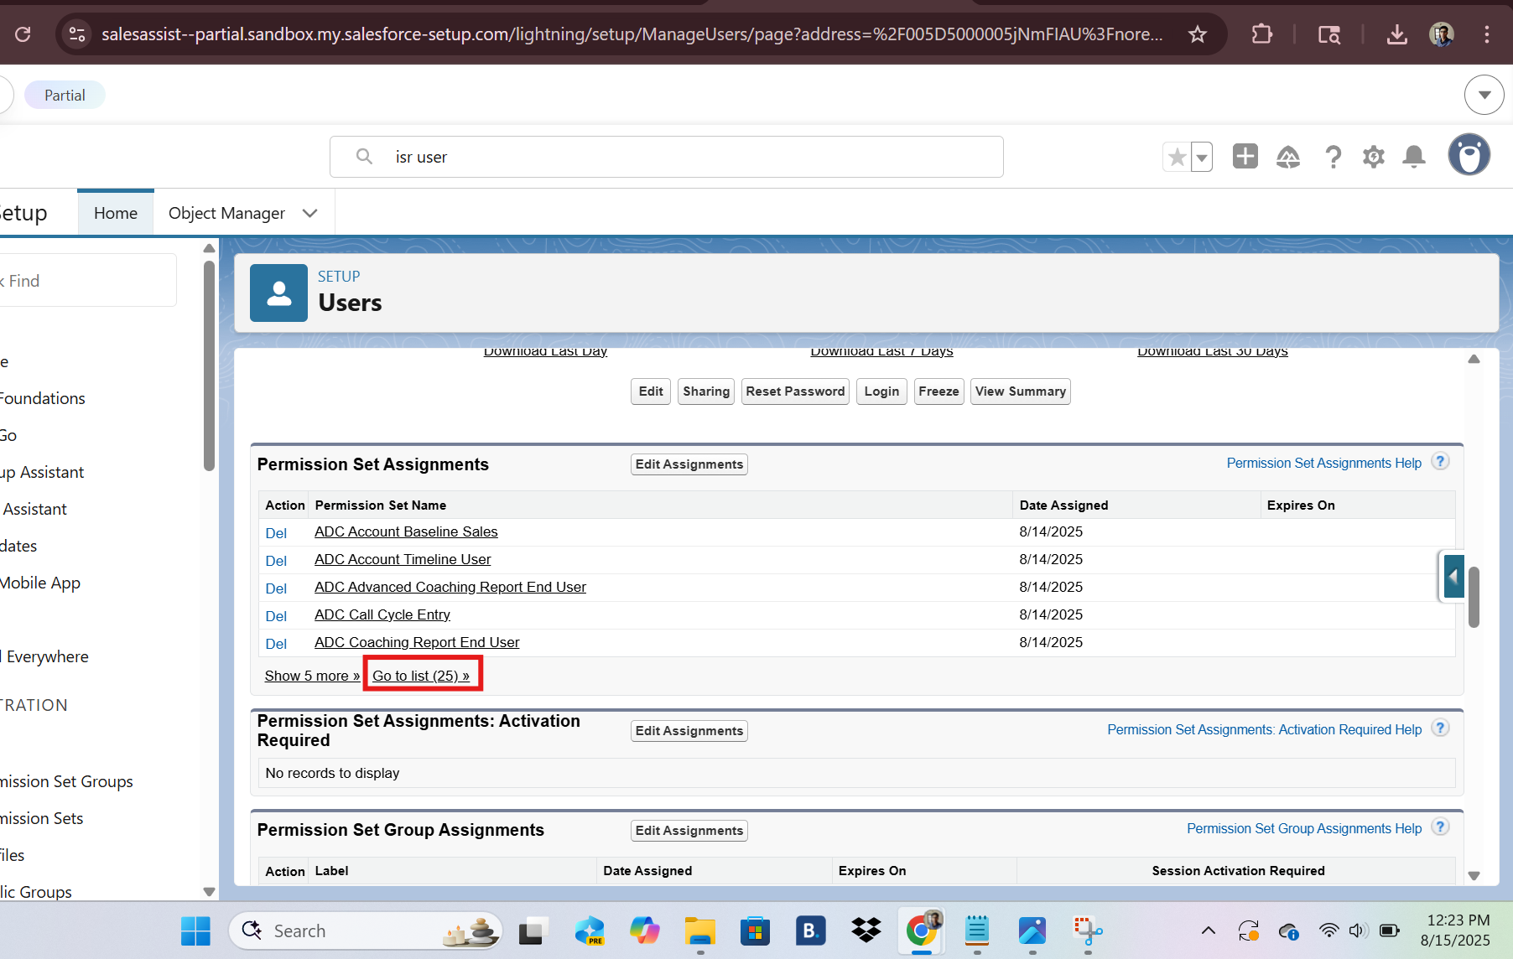
Territory:
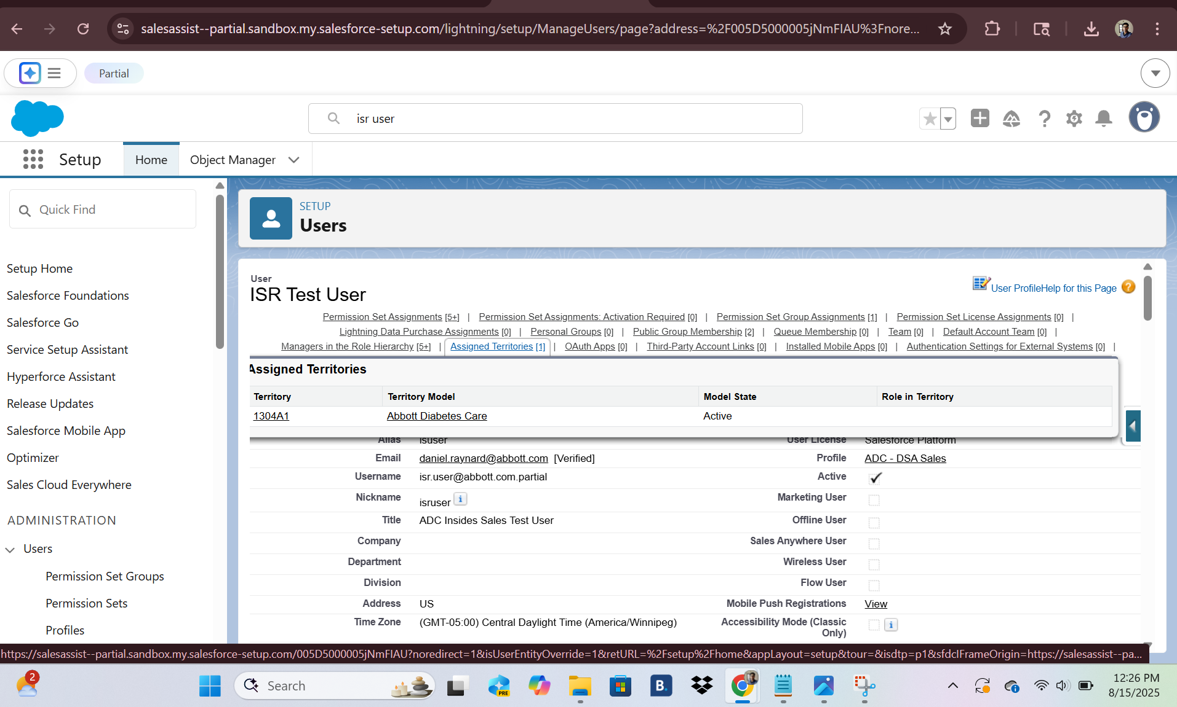
SOQL checks:
Query 1:
-- User → profile
SELECT Id, Name, Username, Profile.Name
FROM User
WHERE Username = 'isr.user@abbott.com.partial'
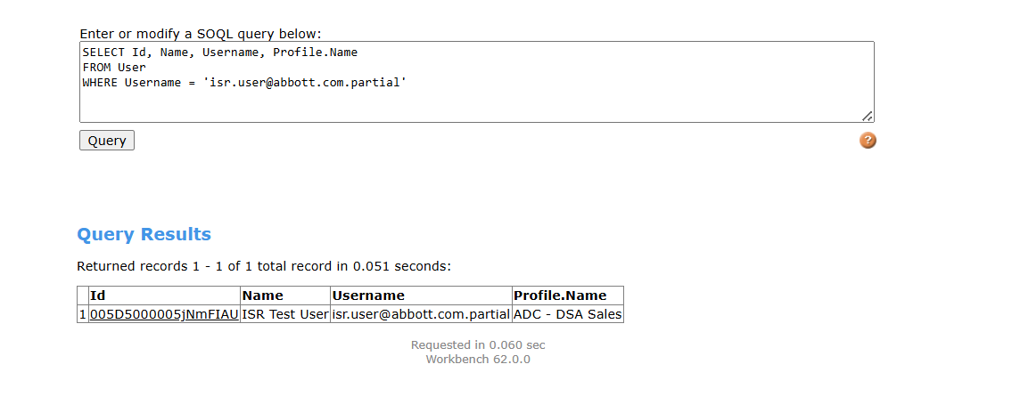
Query 2:
-- What’s assigned
SELECT PermissionSetId, PermissionSet.Label, PermissionSet.Name
FROM PermissionSetAssignment
WHERE Assignee.Username = 'isr.user@abbott.com.partial'
ORDER BY PermissionSet.Name
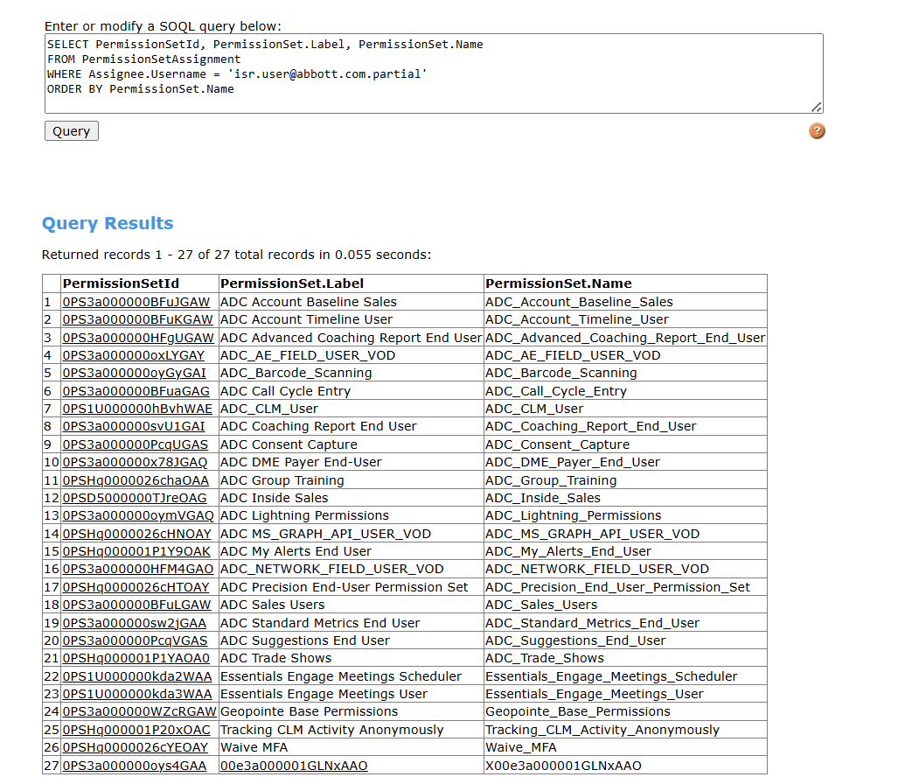
Query 3: Object Access
SELECT ParentId, SobjectType, PermissionsRead, PermissionsCreate, PermissionsEdit, PermissionsDelete
FROM ObjectPermissions
WHERE ParentId IN (
SELECT PermissionSetId FROM PermissionSetAssignment
WHERE Assignee.Username = 'isr.user@abbott.com.partial'
)
AND SobjectType IN (
'Call2_vod__c',
'Remote_Meeting_vod__c',
'Sent_Email_vod__c',
'Medical_Inquiry_vod__c',
'Suggestion_vod__c',
'Product_vod__c',
'vod__MyInsights_Data_vod__c',
'Sample_Order_vod__c',
'Sample_Transaction_vod__c',
'Sample_Inventory_vod__c'
)
ORDER BY SobjectType

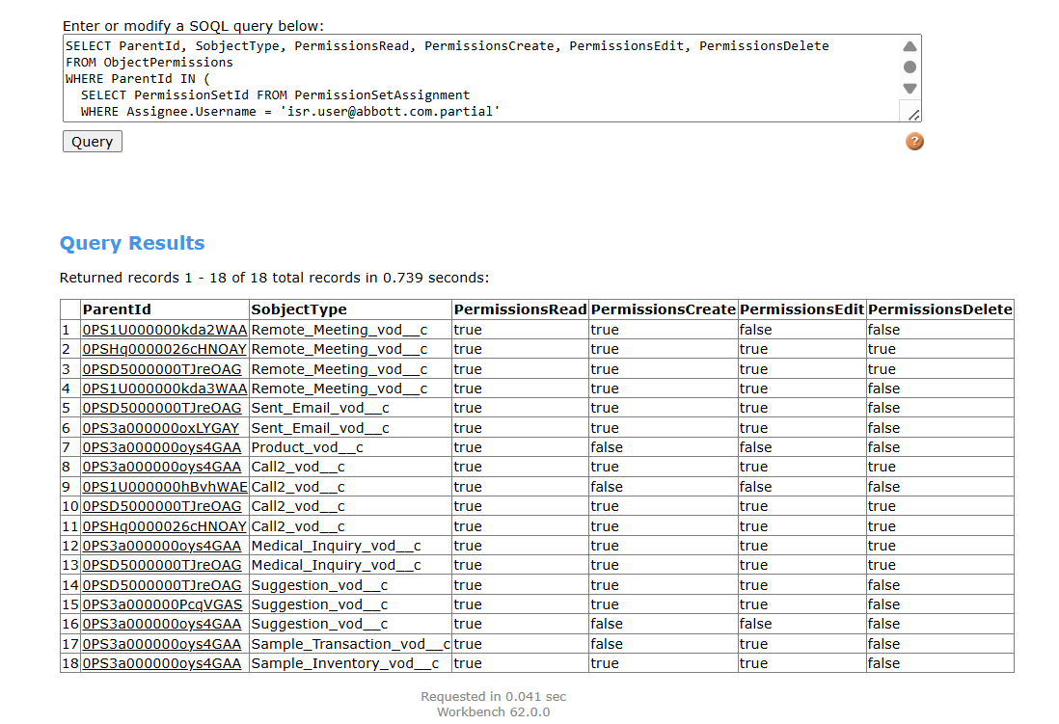
Territory Assignment:
SELECT Territory2.Name, Territory2.DeveloperName, IsActive
FROM UserTerritory2Association
WHERE User.Username = 'isr.user@abbott.com.partial' AND IsActive = true
ORDER BY Territory2.Name

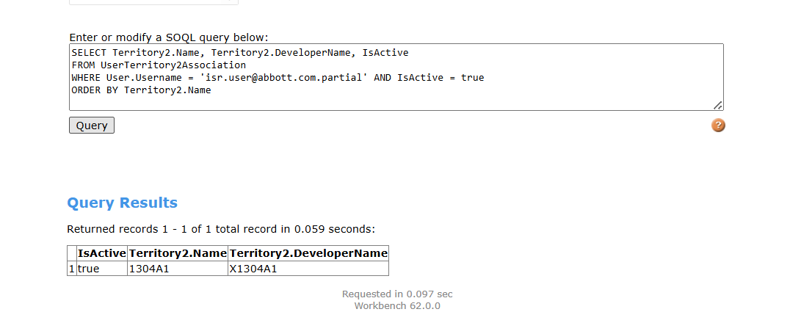

-- Profile baseline
SELECT Id, Name,
PermissionsRunReports,
PermissionsCreateCustomizeReports
FROM Profile
WHERE Id IN (SELECT ProfileId FROM User
WHERE Username='isr.user@abbott.com.partial')
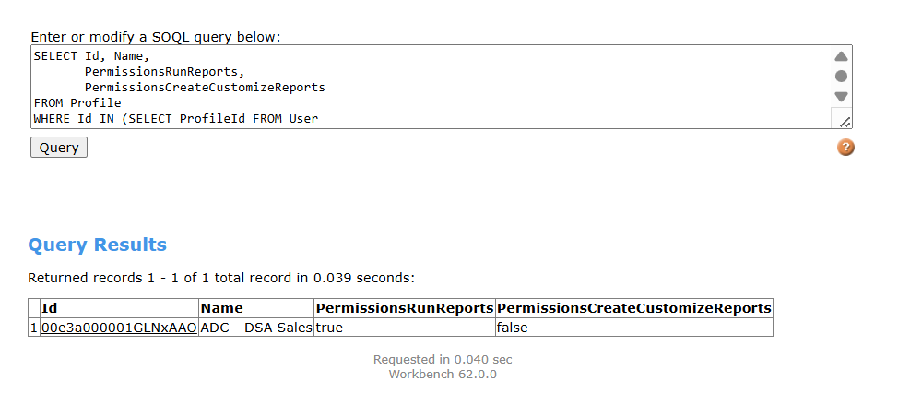

-- Permission Sets that might add perms
SELECT Id, Name,
PermissionsRunReports,
PermissionsCreateCustomizeReports
FROM PermissionSet
WHERE Id IN (
SELECT PermissionSetId FROM PermissionSetAssignment
WHERE Assignee.Username='isr.user@abbott.com.partial'
)
ORDER BY Name
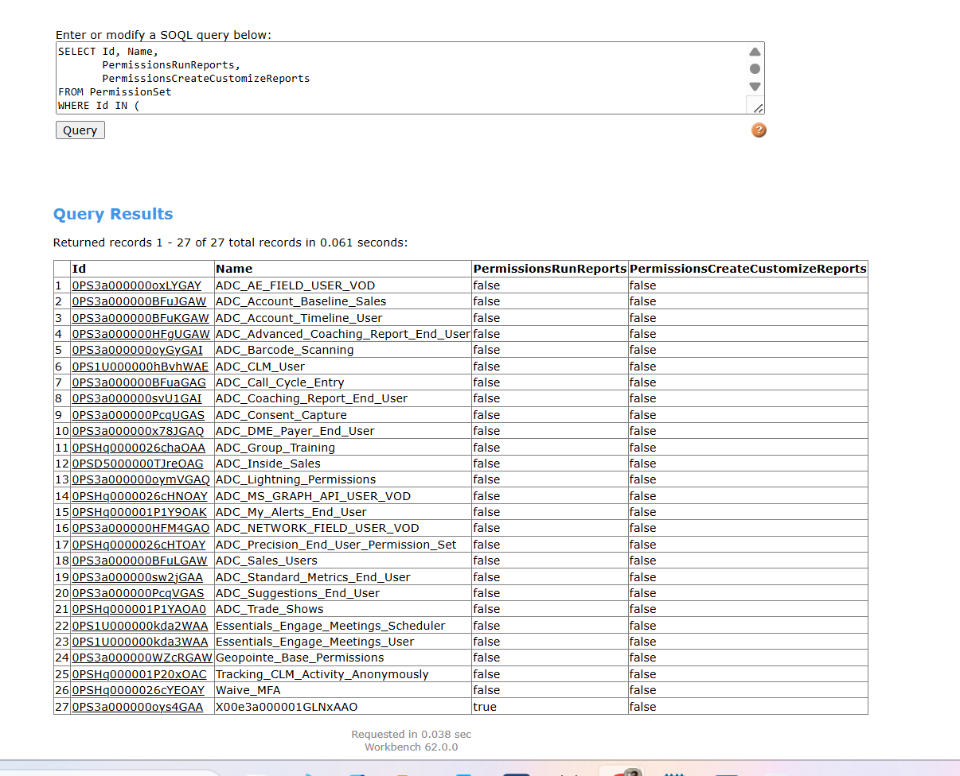
None of the Permission Sets assigned to this Inside Sales user are explicitly granting visibility to the report, dashboard, or MyInsights tabs.
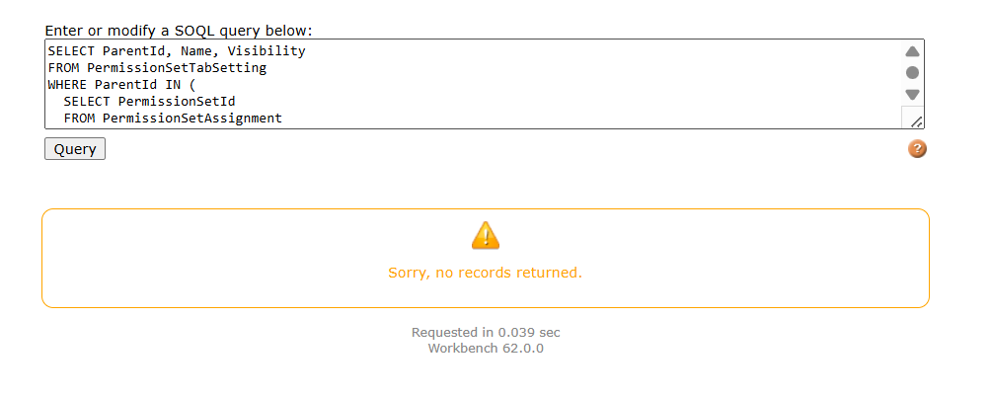
UI Validations:
